Assignment 3

Josephine Hillebrand Hansen

Cognitive Science at Aarhus University

# Question 1) Assess the relation between symptom severity and IQ (focus on visit 1 and children with ASD)

First, I made a subset of the data only including the ASD data and data collected at visit 1. The relation between symptom severity and IQ was assessed for three different types of IQ: Verbal IQ, non-verbal IQ and social IQ.

## VerbalIQ

We assume that verbal IQ is normally distributed, but we investigate the distribution by plotting it, which can also help us motivate our priors! The distribution is slightly skewed towards the right, seem to be highest around verbal IQ = 13 and a max of 40.

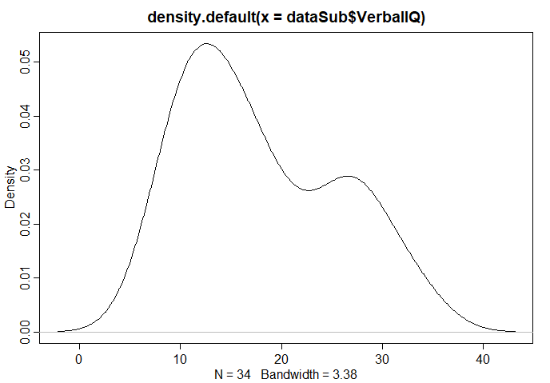

In this case we want to predict ADOS as our outcome measure. The outcome distribution will be a gaussion distribution with a mean, $μ$ and a standard deviation, $σ.$ We want to use verbal IQ as a predictor. Thus the model is given with:

$$ADOS_{i}\sim Normal\left(μ_{i}, σ\right)$$

$$μ_{i}=α+β*verbalIQ_{i}$$

We now move on to define our parameters and $σ$. We define $α$ as a normal distribution centered around 20, as ADOS is more or less 20, when the verbalIQ is centered around 0, with a broad standard deviation of 10, as we are not too sure of this information.

We define $β$ as a normal distribution centered around 0, with a standard deviation of 10. We center it around 0, as we are unsure about the relation between ADOS and verbalIQ and therefore want to allow the model to make its inference. Basically, this prior was chosen because we don’t know anything.

$σ$ will be defined as a uniform distribution between 0 and 30, as 0 is the lowest value of our outcome measure ADOS, and 30 is circa max.

The full model specification follows below:

$$ADOS_{i}\sim Normal\left(μ_{i}, σ\right)$$

$$μ_{i}=α+β*verbalIQ_{i}$$

$$α \sim normal(20,10)$$

$$β \sim normal\left(0,10\right)$$

$$σ \sim uniform(0, 30)$$

All priors are fairly weak. The model was fit using a quadratic approximation, using the function map() in R.

We know get the gaussian approximations of each parameter’s marginal distribution. Thus, we get the posterior. The output is:

|  |  |  |  |  |
| --- | --- | --- | --- | --- |
|  | Mean | Standard deviation | 5.5% | 94.5 % |
| $$α$$ | 21.75 | 1.40 | 19.52 | 23.98 |
| $$β$$ | -0.44 | 0.07 | -0.55 | -0.33 |
| $$σ$$ | 3.16 | 0.38 | 2.55 | 3.78 |

We also plotted the relation between verbalIQ and ADOS together with the posterior inference (black line). From the plot we can clearly see a negative correlation between verbal IQ and ADOS.

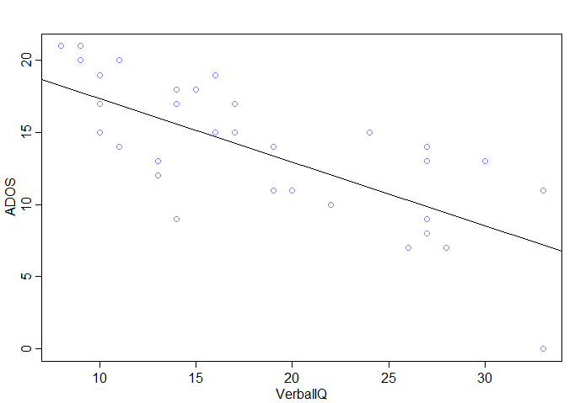

We also made a plot showing the uncertainty of the MAP-line. It is easy to see from the plot below, that the model shows greater uncertainty at extreme values.

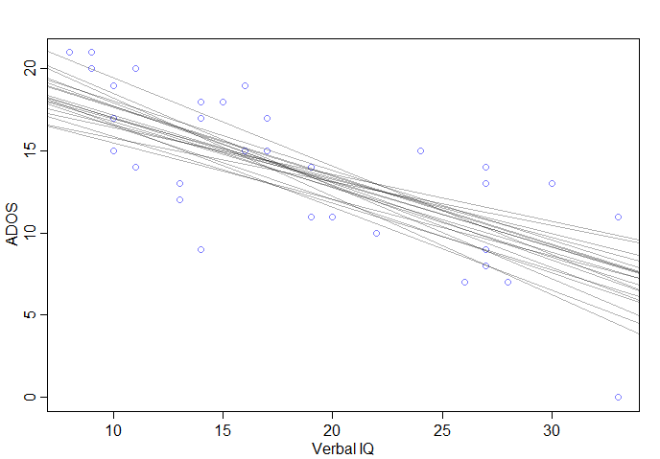

We also plotted the posterior distribution (red line) against the data (black line).

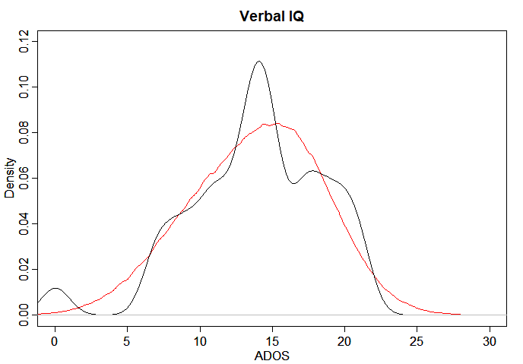

# Question 2) Do the different aspects of IQ account for different portions of variance in ADOS?

## Question 2.1 Does it make sense to have all IQ measures in the same model?

There are two different hypothesis that answers whether it makes sense to have all IQ measures in the same model. If we assume that there is an underlying general intelligence factor, then we would assume that the IQ measures might be collinear. An alterative hypothesis is that there are different types of intelligences that might not be correlated, and therefore adding a new type of IQ to the model will always add new and valuable information.

The issue with adding more predictors is that if they are collinear, it will make the beta-values uninterpretable. Thus, we can no longer say, for example, that each increase in verbal IQ will lead to a specific decrease in ADOS.

To investigate whether different aspects of IQ account for different portions of variance, the data for verbalIQ, nonverbal IQ, social IQ and ADOS was first scaled and then centered.

First we made a plot using the function pairs() to investigate visually the correlation between both the outcome, ADOS, and the three predictors, as well as the correlation between the three different predictors. The plot can be seen below.

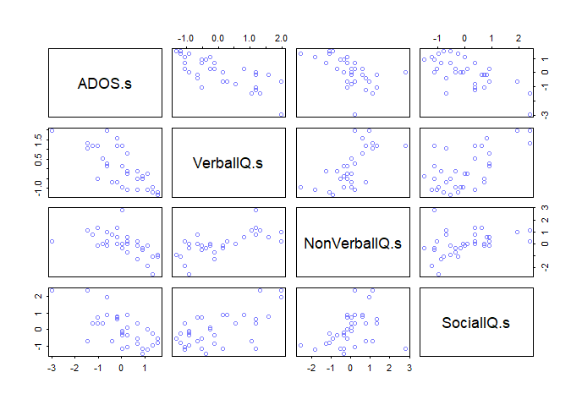

Now we will build a model to investigate collinearity amongst the predictors. We will look at the correlation between beta values. We build a model predicting ADOS from verbal IQ, nonverbal IQ and social IQ.

We will build the following model:

$$ADOS_{i}\sim Normal\left(μ_{i}, σ\right)$$

$$μ_{i}=α+βv*verbalIQ_{i}+βn*nonverbalIQ_{i}+βs*socialIQ_{i}$$

As we have now scaled and centered the data, our priors will also be different from above. $α$ will now be centered around zero and we assume a standard deviation of 2.

$$α \sim normal(0,2)$$

$βv$ will be a normal distribution centered around 0 with a standard deviation of 1. We center it around zero as we don’t know anything about the correlation between verbal IQ and ADOS now that we add the other predictors as well. The same goes for $βn$ and $βs$.

$$βv \sim normal\left(0,1\right)$$

$$βn \sim normal\left(0,1\right)$$

$$βs \sim normal\left(0,1\right)$$

Sigma is a uniform distribution between 0 and 10.

$$σ \sim uniform(0, 10)$$

By plotting the beta-values and their 89% intervals we get the plot that can be seen below. As it can be seen, the beta-value for non-verbal IQ overlaps with zero. Even though, it just slightly overlaps with zero, it seems that there is not necessarily any additional explanatory value added from including nonverbal IQ as a predictor, when we already have verbal IQ and social IQ as predictors.

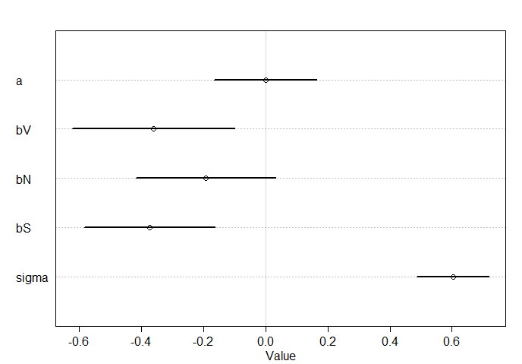

The correlation between the different predictors was also found.

* The correlation between verbal IQ and non-verbal IQ was found to be -0.60.
* The correlation between verbal IQ and social IQ was found to be -0.52.
* The correlation between social IQ and non-verbal IQ was found to be 0.06.

Thus, verbal IQ seems to be correlated with both non-verbal IQ and social IQ. However, social IQ and non-verbal IQ does not seem to be correlated with each other.

Thus, it seems that non-verbal IQ does not explain a different portion of variance if we already have verbal IQ and social IQ. And even though verbal IQ and Social IQ is somewhat correlated, there is still value in including both in our model.

We also plotted the data and the posterior distribution together again, to see if the posterior distribution matches the data. It fits more or less, however there is some variance in the data not captured by the posterior distribution. This is due to our assumption of the data as a Gaussian distribution.:

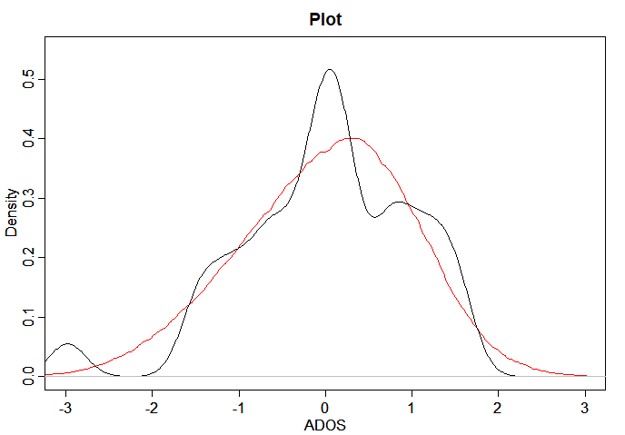

# Question 3)